Question 1:

#include<stdio.h>

int main()

{

int n,i;

printf("enter the size of array:");

int arr[n];

scanf("%d",&n);

printf("enter the elements of array:");

for(i=0;i<n;i++)

{

scanf("%d",&arr[i]);

}

printf("enter the elements in array");

for(i=0;i<n;i++)

{

printf("%d",arr[i]);

}

printf("\n");

return 0;

}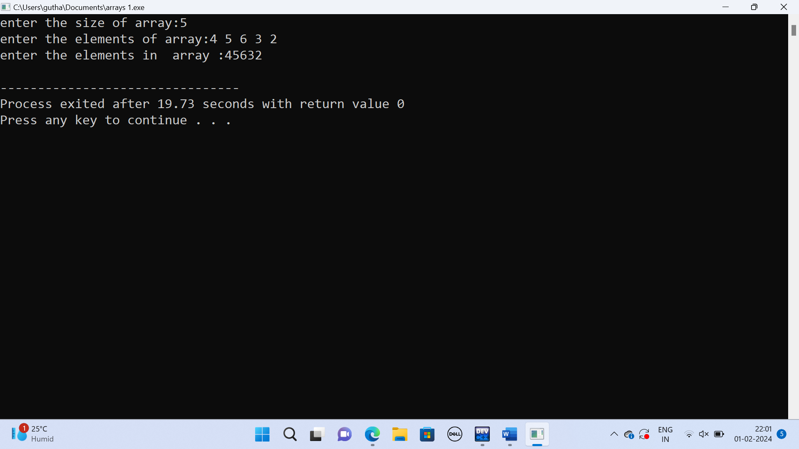

Question 2:

#include<stdio.h>

int main()

{

int n,i;

printf("enter the size of array:");

scanf("%d",&n);

int arr[n];

printf("enter the elements of array:");

for(i=0;i<n;i++)

{

scanf("%d",&arr[i]);

}

printf("enter the elements in array :");

for(i=n-1;i>0;i--)

{

printf("%d",arr[i]);

}

printf("\n");

return 0;

}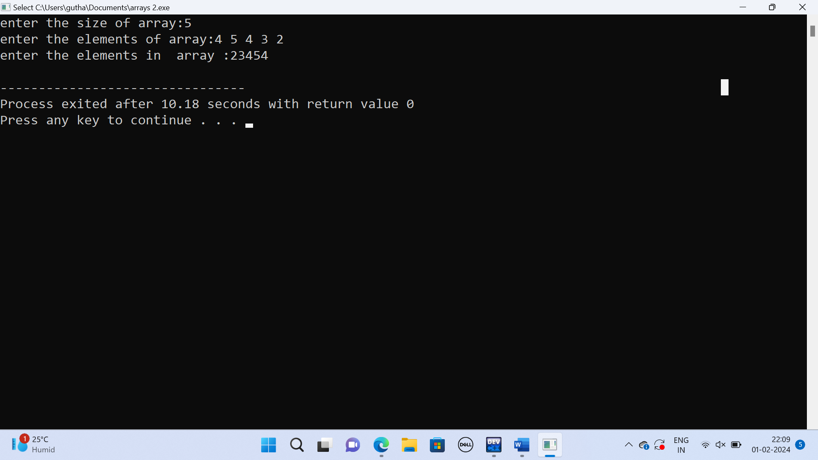

Question 3:

#include<stdio.h>

int main()

{

int n,I,sum=0;

printf("enter the size of array:");

scanf("%d",&n);

int arr[n];

printf("elements of an array:");

for(i=0;i<n;i++)

{

scanf("%d"&,arr[i]);

sum=sum+arr[i];

}

printf("sum=%d",sum);

return 0;

} 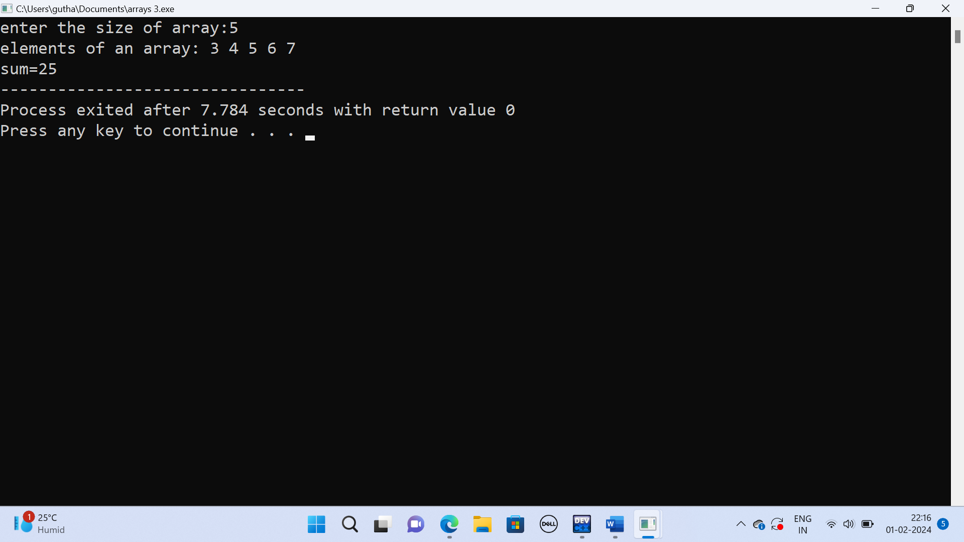

Question 4:

#include <stdio.h>

#include <conio.h>

int main() {

int arr[100], size;

printf("Enter the size of the array: ");

scanf("%d", &size);

printf("Enter the Elements of the array: ");

for (int i = 0; i < size; i++) {

scanf("%d", &arr[i]);

}

printf("Unique Elements in the array are: ");

for (int i = 0; i < size; i++) {

int count = 0;

for (int j = 0; j < size; j++) {

if (arr[i] == arr[j]) {

count = count + 1;

}

}

if (count == 1) {

printf("%d ", arr[i]);

}

}

return 0;

} 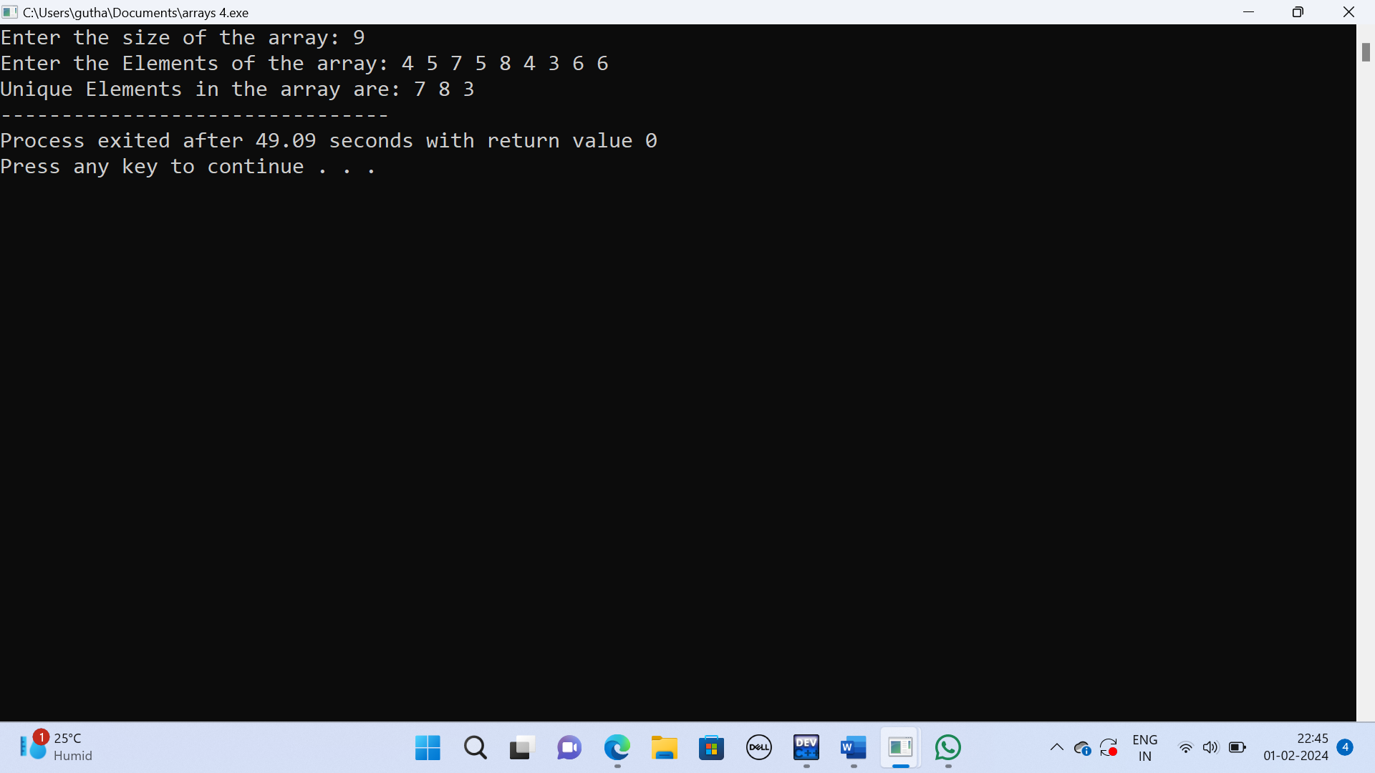

Question 5:

#include <stdio.h>

int main()

{

int array[100], position, c, n;

printf("Enter number of elements in array\n");

scanf("%d", &n);

printf("Enter %d elements\n", n);

for ( c = 0 ; c < n ; c++ )

scanf("%d", &array[c]);

printf("Enter the location where you wish to delete element\n");

scanf("%d", &position);

if ( position >= n+1 )

printf("Deletion not possible.\n");

else

{

for ( c = position - 1 ; c < n - 1 ; c++ )

array[c] = array[c+1];

printf("Resultant array is\n");

for( c = 0 ; c < n - 1 ; c++ )

printf("%d\n", array[c]);

}

return 0;

} 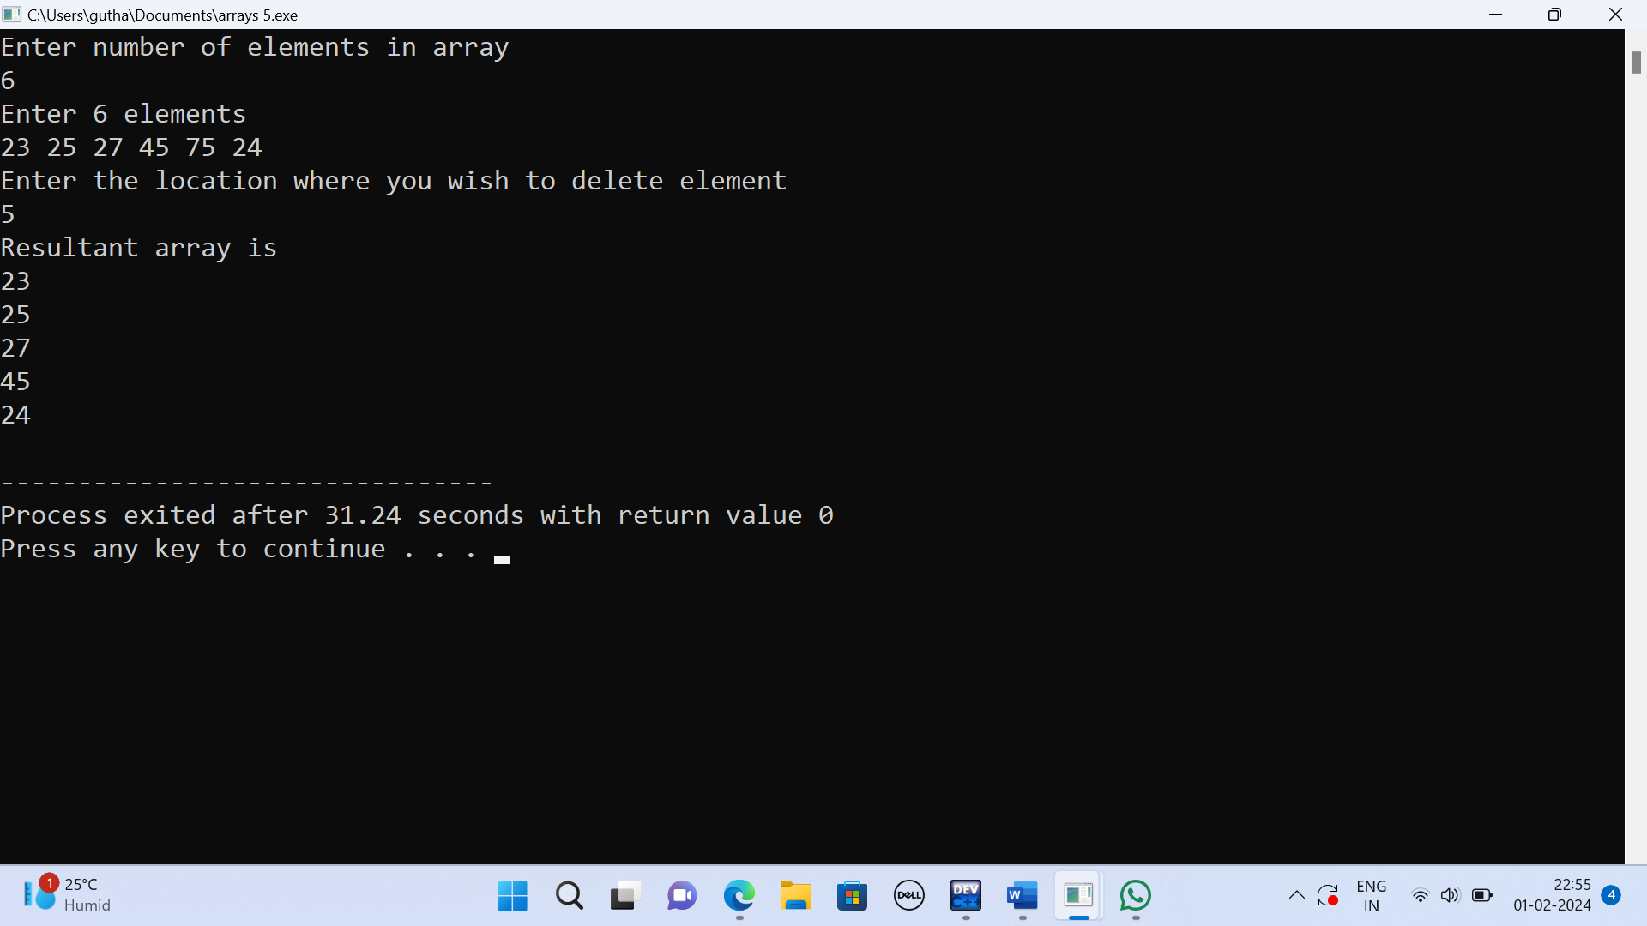

Question 6:

#include <stdio.h>

int main()

{

int arr[100];

int n, mm = 1, ctr = 0;

int i, j;

printf("Input the number of elements to be stored in the array :");

scanf("%d", &n);

printf("Input %d elements in the array :\n", n);

for (i = 0; i < n; i++)

{

printf("element - %d : ", i);

scanf("%d", &arr[i]);

}

for (i = 0; i < n; i++)

{

for (j = i + 1; j < n; j++)

{

if (arr[i] == arr[j])

{

ctr++;

break;

}

}

}

printf("Total number of duplicate elements found in the array: %d\n", ctr);

return 0;

} 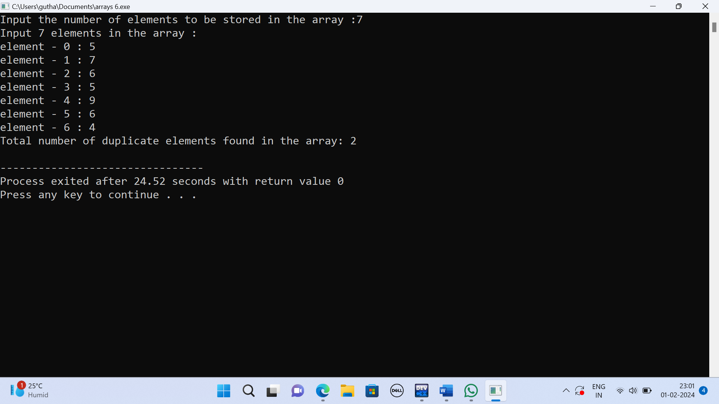

Question 7:

#include<stdio.h>

int main()

{

int array[50], position, c, n, value;

printf("Enter number of elements in the array\n");

scanf("%d", &n);

printf("Enter %d elements\n", n);

for (c = 0; c < n; c++)

scanf("%d", &array[c]);

printf("Please enter the location where you want to insert an new element\n");

scanf("%d", &position);

printf("Please enter the value\n");

scanf("%d", &value);

for (c = n - 1; c >= position - 1; c--)

array[c+1] = array[c];

array[position-1] = value;

printf("Resultant array is\n");

for (c = 0; c <= n; c++)

printf("%d\n", array[c]);

return 0;

} 